MILESTONE EVALUATION SHEET

MILESTONE NO.
4

DATE: | COURSE NO.: ISMG 6060
 | INSTRUCTOR: Ersin Dincelli

TEAM NO. OR NAME | TEAM MEMBERS
 | Yash Nigam

Student comments:

Instructor comments:
Use Case Diagram
Need to show subject boundary.
Use Case Description
In use case type, need to indicate whether it is essential or real as well.
In Relationships section, need to include all actors related to the use case in Association.
The events recorded in use case descriptions and activities in the activity diagram have to match with each other.

Score:9.5
Use Case Diagram for PSSM

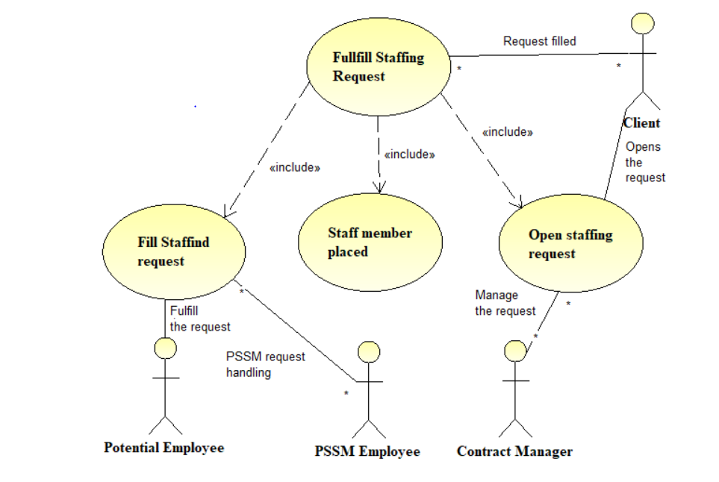

Activity Diagram

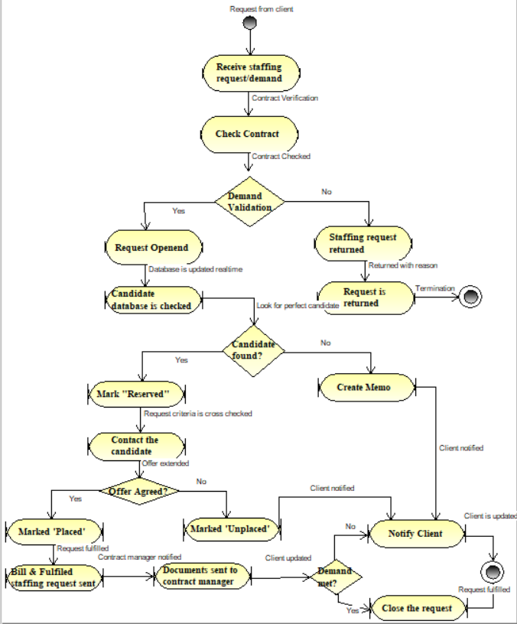

Use Case Description

Use Case Name: Fulfill staffing request |  | ID: 1 | Importance Level: High
Primary Actor:  Client | Use Case Type: Overview
Stakeholders and Interests:
Client
Brief Description: Contract manager at PSSM receives the client demand and verifies the client contract, placement department investigates the consolidated database to match the requirements and the arrangement department negotiates placement terms and send the candidate to the client.
Trigger: Client puts in a request to fulfill their demand for a staff member
Type: External
Relationships:
Association: Contract manager, placement manager and arrangement manager
Include: Client
Extend:
Generalization: Fulfill staffing requests and update the database
Normal Flow of Events:
- Contract manager opens the staffing request submitted by the client
- Placement department finds a suitable fit for the request from their database
- Arrangement department negotiates the terms and condition of the opportunity
SubFlows:
- Contract with the client is verified first, then the request is forwarded
- The client is notified if the request is accepted or denied
- The client has the access to candidate database where they can look the candidate of their own choice
- With real-time tracking and notification, updates are sent to all departments about the process and fulfillment
Alternate/Exceptional Flows: When a request is not fulfilled, the client is notified with reason, all the other processes are carried out by the contract department at PSSM.

Use Case Name: Open staffing request |  | ID: 2 | Importance Level: High
Primary Actor: Client, Contract Manager | Use Case Type: Detailed
Stakeholders and Interests:
Contract manager, candidate, placement department
Brief Description: A new staffing request is received by PSSM, contract manager reviews the terms with clients
And puts the request in the database to find a suitable candidate for the role. If the demand is not valid, the request is sent back to the client with the explanation.
Trigger: Client puts the request in the database system or via phone, email and requests a demand
Type: External and Internal
Relationships:
Association: Contract manager, placement manager
Include: Client
Extend: Valid request
Generalization: Update the database with new request and contract verification with client
Normal Flow of Events:
- Client demands a new temporary staff, they put in a request for the same
- Contract manager reviews the contract deal with the client
- Contract manager validates the request and request proceeds in the database
- Placement department is notified of the new requirement.
SubFlows:
- The contract is matched with the contract no. and the details that the client has put in the request
- Database flags and acknowledges the request and proceeds to notify the placement department
- Placement department works on the request and verifies the requirements and the available candidates
Alternate/Exceptional Flows:
If the request is invalid i.e the contract details do not match the request details, a letter is generated and sent to the client notifying about the reason and measure to eliminate it.

Use Case Name: Place staff member |  | ID:3 | Importance Level: High
Primary Actor:  Placement Department | Use Case Type: Detailed
Stakeholders and Interests:
Placement department, contract manager, arrangement department, candidate
Brief Description: The placement department verifies the position, qualification, and experience of the candidate mentioned on the request and matches it in the database.
Trigger: After approval from the contract manager, the database sends the staffing request to the placement department to look for a suitable candidate to meet the client’s requirement.
Type: Internal
Relationships:
Association: Placement department, candidate
Include: Client
Extend:
Generalization: Find the right candidate
Normal Flow of Events:
- An employee from the placement department checks the position, qualification, and experience specified in the staffing request in the database
- If the perfect candidate is found, they are marked as ‘Reserved’
SubFlows:
- The database gives all the available candidates matching the client's request.
- The database forwards these details to the arrangement department notifying them about the possible matches
Alternate/Exceptional Flows:
If a candidate is not found in the database, an ‘unable to fill’ memo is generated and sent to the arrangement department to further pass it on to the client or the contract manager.

Use Case Name: Fill Staffing request |  | ID: 4 | Importance Level: High
Primary Actor: Arrangement Department, Candidate | Use Case Type: Detailed
Stakeholders and Interests:
Client, candidate, arrangement department
Brief Description: A candidate is contacted, and the details and negotiations are discussed and agreed upon. The candidate details are forwarded to the client and they report to the client. The staffing request is closed
Trigger: Possible candidate marked as ‘reserved’ in the database and the arrangement department is notified
Type: Internal / External
Relationships:
Association: Candidate, Clients and arrangement department
Include:
Extend:
Generalization: Put the right candidate on the job and close the client request
Normal Flow of Events:
- Arrangement department contacts the candidate
- Details are settled and discussed with negotiations
- The candidate is placed with the client by the PSSM employee
- The staffing request is closed.
SubFlows:
- Database marks the candidate as placed
- Database closes the staffing request
- Copy of bill and staffing request is sent to the client
- If the candidate is not found, the additional memo is sent to the client
Alternate/Exceptional Flows: If the staffing request is not fulfilled, the memo is filed by the contract manager.

Functional Model Verification and Validation
-One event of a use case description is present in each activity in the activity diagram
-In the activity diagram, all objects show as object nodes are in events of the use-case diagram.
-The orders of events in the use case diagram are the same as the order in the activity diagram.
-Each use case diagram has a use case description.
-All the actors in the use case description are matching the use case diagram.
-In the use case description, the stakeholders are shown as actors for use case diagram.
-All the relationships from use case description are shown in the use case diagram.
-All the UML standards are followed by the use case diagram.

